**WELCOME**

**TO**

**NORTON ST PHILIP**

**A GUIDE TO THE VILLAGE, ITS ORGANISATIONS AND ACTIVITIES**

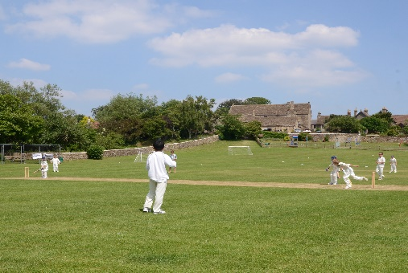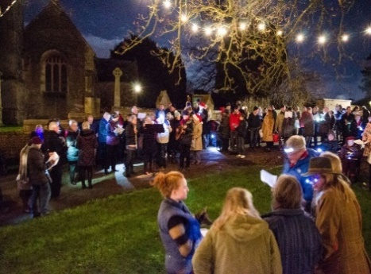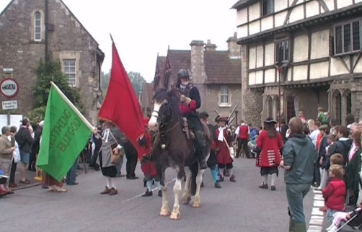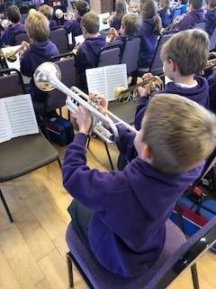

**Welcome**

Whether you have moved in recently or been here for several months, we welcome you to the village and hope you will find that this guide provides you with essential information about our village. Norton St Philip is an active community with many organisations. We have tried to list them here by way of an introduction.

As with any organisation, our village communities thrive or fall away based on the level of support they achieve. You will receive a welcome from them all and we hope you will want to join at least some of them. Together these organisations form a rich tapestry that make our village more than just a picture postcard for tourists but a busy, active and friendly place to live.

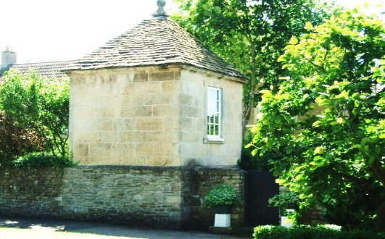

Contents

**Subject Page**

Churches 4

Church Groups and Activities 6

Schools 11

Children and Young People 13

Sports and Fitness 15

Drama, Film 17

Arts and Crafts 17

Shop 19

Library Services 19

Pubs 20

Doctors and Hospitals 22

Public Transport 22

MP and Local Government 23

Refuse Collection 26

Friends of St Philip & St James 27

Website and Parish News 28

**CHURCHES**

Our parish is called Hardington Vale and incorporates; Farleigh Hungerford, Faulkland, Hemington, Laverton, Norton St Philip, Rode, Tellisford and Woolverton.

St Philip and St James is the village church and has a Holy Communion service in the morning on the second and fourth Sunday of every month at 10.30 am.

On the first Sunday of the month we hold a breakfast church at 0900 and everyone is welcome. An informal service is held on the third Sunday and when there is a fifth Sunday the whole parish combines moving around the churches in turn. Full details of all the services can be found on the Parish website [www.hardingtonvale.org.uk](http://www.hardingtonvale.org.uk) or in the church porch.

The Rector for the Parish lives in a bungalow next to the church in Norton St Philip. Rev’d Caroline Walker can be contacted by email [carolinehwalker@btinernet.com](mailto:carolinehwalker@btinernet.com) or Tel: 01373-834258. The Curate, Rev’d Jo Robinson, is based in Rode and can be contacted on Tel: 01373-831381 or 321jorobinson@gmail.com. The Parish also has a Childrens and Families Worker, Sue Rodford. More about Sue and her work can be found later in the leaflet.

The Parish Office, which is situated in the church itself, is open Monday, Tuesday and Wednesday 8.30 am – 12.30 pm. Ros Clarke is the Parish Administrator [admin@hardingtonvale.org.uk](mailto:admin@hardingtonvale.org.uk) Tel: 01373-834488.

**Norton Gospel Chapel**

Situated on the High St in Norton St Philip, the Chapel has a weekly service on a Sunday at 10.15 am with breaking of the bread at 11.30 am.

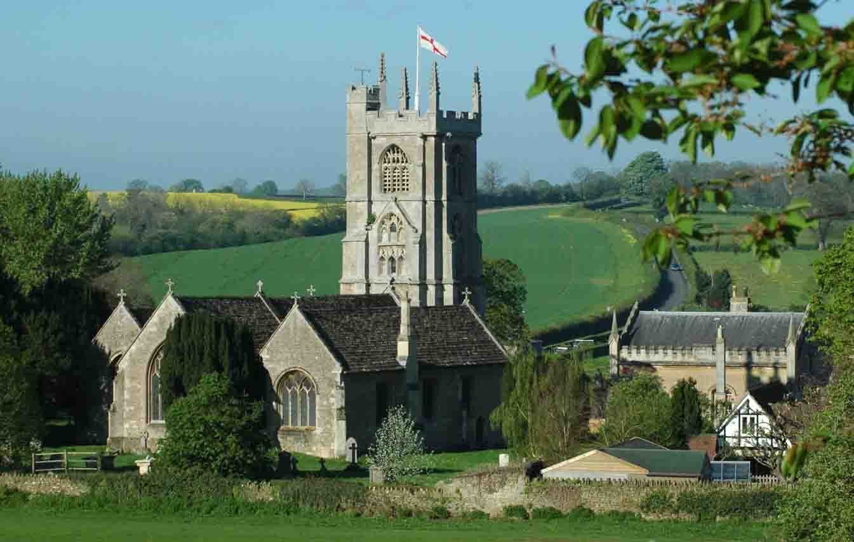

**Roman Catholic Church**

The nearest Roman Catholic church is St Catharine’s Catholic Church, Frome or Saint Dominic’s Catholic Church, Mells. <http://www.stcatharines.co.uk/parish-groups.aspx>

Downside Abbey service times are also available <http://www.downside.co.uk/benedictine-monastery/downside-abbey-church/downside-abbey-service-times/>

**CHURCH MUSIC**

**Choir:** If you would like to be involved in the ad hoc choir which sings at special services such as Christmas, Harvest, Easter, please contact Caroline Whitehead [caroline@whatcombefarm.com](mailto:caroline@whatcombefarm.com) to add your name to the list of potential singers. Rehearsals for these special events normally take place in the evenings in the week preceding the service. Caroline contacts the singers either by phone or email whenever a performance is planned.

**Bell Ringers:** practise on Thursday evenings. New ringers are always welcome and tuition will be arranged for any new volunteers. Please contact the Tower Captain: John Curtain 01373 834610.

**CHURCH GROUPS**

**Prayer Groups**: A number of prayer groups meet across the Parish. Some meet in the afternoon, others in the evenings. Some run most of the year; others just for certain seasons of the year such as Advent or Lent. If you interested in joining one of these please contact the Rector.

The **Clock Winders**: are a small group of mechanically-minded enthusiasts, who take turns to wind the clock mechanism twice weekly as well as meet socially a few times during year to discuss ‘clock-winding policy’ in the Fleur de Lys pub. Chief Clock Winder is Martin Clarke (tel: 834352).

**The Church Clock:** The church tower has a clock dating from 1848 by Benjamin Lewis Vulliamy, a clockmaker of Swiss origin. Other Vulliamy clocks can be seen at Hampton Court (1799), London Horse Guards (1816) and Windsor Castle (1829) as well as in many stately homes - some not too far from Norton St Philip.

**Flower Arrangers**: New flower arrangers are always welcome to help decorate the church for festivals and weddings. Please contact Jenny White Tel: 01373-834601.

**Churchyard:** If you are willing to help with the maintenance of the churchyard please contact the Churchyard Lead, Duncan Barley email: [barleyhome@aol.com](mailto:barleyhome@aol.com)

Opening and Closing Church – If you would like to volunteer to open/close the church – for which there is a daily rota – please contact Robin Finlay who compiles the rota. Tel: 01373-834475.

**Coffee Morning** with sale of cakes, preserves, surplus garden produce etc. takes place on the **1st Saturday each month 10.00 am - 11.30 am** in the church. This is an opportunity to meet and make friends.

**Special Interest**

**The Royal British Legion**

[](http://www.britishlegion.org.uk/)

The Royal British Legion is the UK’s leading Armed Force charity and one of its largest membership organisations. Members get together through the network of branches and clubs all over the country and overseas to participate in social, fundraising and welfare activities. Membership is open to everyone. If you have an interest in the objectives of the Legion and want to help and support those who have served and their families, come and join us. We welcome men and women of all ages whether they have served in the Armed Forces or not. Please contact our Secretary Mrs Ruth Barley [ruthbarley@aol.com](mailto:ruthbarley@aol.com) or Tel: 01373-834127.

**Women’s Group**

Norton Women’s Group is a friendly independent social group. We hold monthly meetings, usually with a short talk from a speaker, followed by coffee and time to chat. Non- members are welcome. We meet on the 3rd Wednesday in the month at 7.45pm in the Palairet Hall. We hold social events in the summer, organise visits to places of interest and local theatre, enjoy a Christmas Lunch, and participate in Village events. It’s a good way to meet people and we’d love you to join us. For more information contact: Nicky Jefferson 0777 6286 646 or Angela Awan 01373 834184.

**Tuesday Drop In**

Fancy a natter and a cup of tea or coffee and a freshly-baked scone? Pop along to the Palairet Hall on Tuesday morning from 10.30 am until 1.30 pm. [](http://www.google.co.uk/imgres?imgurl=http://www.splenda.co.uk/sites/default/files/scones_xlge_0.jpg?1360319557&imgrefurl=http://www.splenda.co.uk/recipes/traditional-cream-tea-scones&h=490&w=870&tbnid=HBdS0PcKcL7IcM:&docid=T_8fWBOF8AOyIM&ei=40PcVbaqLLDA7AbEkofQDg&tbm=isch&ved=0CD4QMygJMAlqFQoTCPanpteDxMcCFTAg2wodRMkB6g)We are there every Tuesday and the first Tuesday of the month we have a light lunch starting at 12 noon. Everyone is welcome. We don’t charge but you can make a small donation if you wish. If you have a book you have read and would like to swap it, bring it along with you. We have a great number, some new, to choose from. We will be there with the kettle on! Hope you will be too! *Jenny White and Muriel Duckett.*

**Palairet Hall, Church Street**

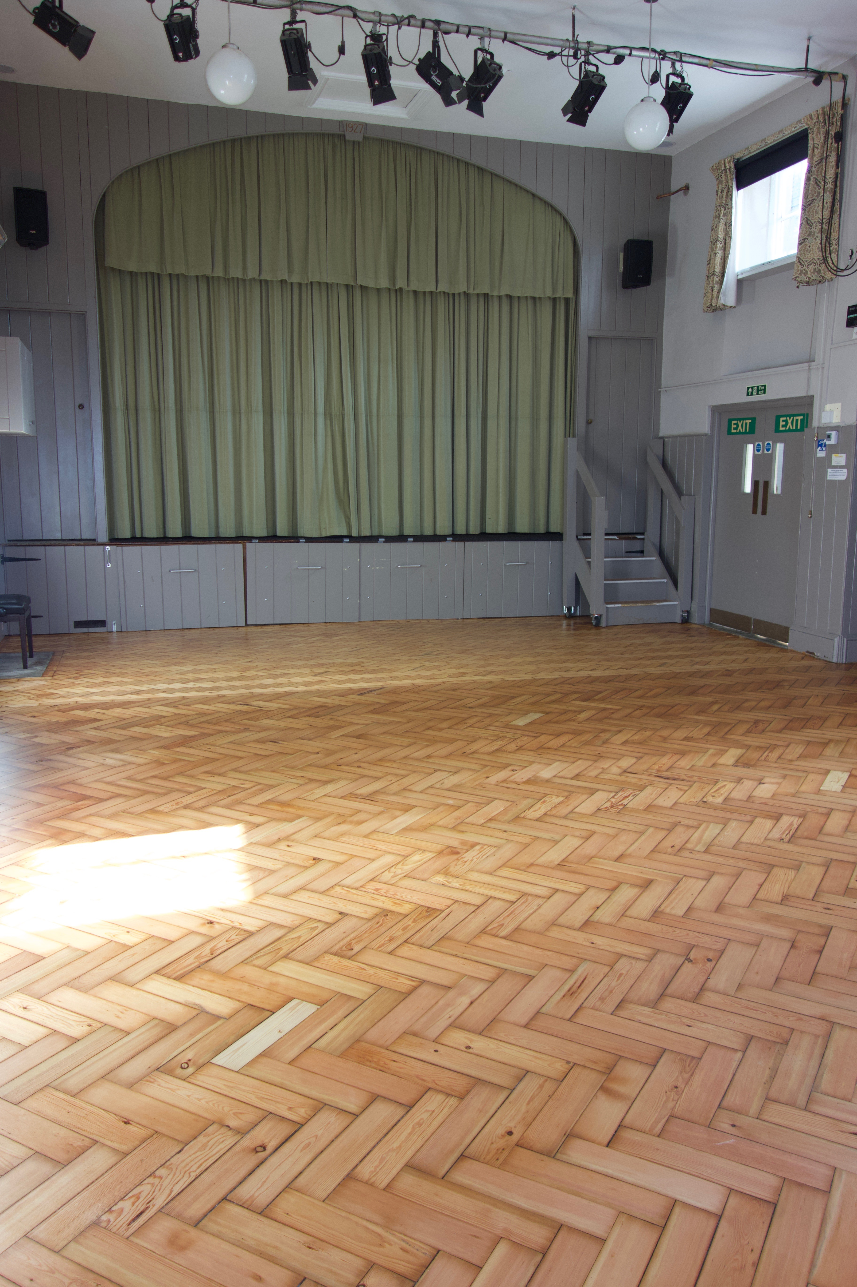The Palairet Hall is the village hall and can be hired by the hour or session or whole day or days. It is located in Church Street, near to the junction with Wellow Lane. The Palairet Hall comprises a large main hall space with proscenium stage and lighting and a bar or mini kitchen, a smaller ‘Committee Room’ and a fitted kitchen with cooker, fridge and power points. It also has a modern projection and sound system together with a large screen suitable for ‘cinema’ style projection. The whole set up can be used either by a laptop or to play DVDs. In addition there is a main kitchen with cooker and separate room that can be used for small meetings. The hall is used by village activity and social groups as well as for ‘craft fayres’, production of plays, monthly film nights, parties and celebrations for all ages.

The Hall has gas central heating as well as supplementary electric radiant wall heaters in the main hall. It has seating and tables for up to 80 people depending on the type of event, together with crockery and cutlery.

The Palairet Hall hire rates are set as ‘community rates’ to encourage the greater use of this facility, and recognises the support received from the Parish Council. The Palairet Hall is run by a small Management Committee.

To book the Palairet Hall for an event or for more information, please call 01373 834414.

**Churchmead**

Church Mead is at the heart of the village and is much used and appreciated by residents for leisure activities and as a tranquil green space.

Church Mead is held in trust by the Parish Council and is run by the Church Mead Management Committee which is an independent charity. Members of the committee represent various organisations in the community and it also welcomes interest from other residents.

The committee looks after the maintenance of the Mead and raises funds for its upkeep including the children's play area and the pavilion. They organise an annual Bonfire and Firework Party in November. For more information contact the Chairman, Jan Scarrow: janscarrow@aol.com

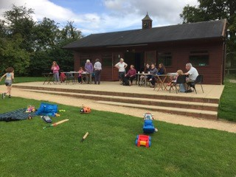

**SCHOOLS**

**Pre-School**

Our friendly village pre-school was rated Good in the latest Ofsted report. We aim to ensure our children learn happily through play, giving individual attention to the needs and development of each child.

Based in a custom designed building, we have excellent play and learning facilities including an all-weather outdoor play area.

Website; [www.nortonpreschool.co.uk](http://www.nortonpreschool.co.uk) Telephone; 01373 834628 Email; [info@nortonpreschool.co.uk](mailto:info@nortonpreschool.co.uk)

**Rode and Norton St Philip School Federation**

**Inspire, Explore, Discover, Create, Flourish**

**Small Schools, Thinking Big!**

Welcome to our Rode and Norton St Philip First School Federation where we like to do things a little bit differently. We are developing a unique learning experience across our two village schools. Our aim is to create the ‘best of both worlds’ education model; combining the small, nurturing, individualised village school experience, with the rich and varied learning opportunities often only found in larger schools. With single year group classes in idyllic rural locations we are able to offer children a very special start in life that we believe will help to share their successes for years to come.

**Technology and Trees**

Our Federation recognises the importance of providing children with inspirational opportunities to challenge their growing bodies and minds. We offer swimming lessons from Reception, daily lunchtime play leadership from specialist sports coaches and plenty of natural outdoor space for exploration, activity and reflection. Our spacious playing fields host weekly Forest School workshops to consolidate and extend classroom-based learning in the natural environment. Break time is welly time and children at both sites hit the grass running. Our innovative approach is supported by the very best of contemporary learning technology. All of our classrooms have state of the art interactive whiteboards, MacBook Pro laptops and iPads.

**Early Years**

Children begin their learning adventure at the Norton St Philip site. Learning is centred around play, be it developing phonic knowledge by digging for treasure in the giant sandpit, learning maths skills whilst cooking up a storm in the outdoor kitchen café, building in our woodwork shed or taking tea in the playhouse. The children have free access to a wide variety of multi-purpose resources, the beautiful natural environment and our highly trained staff, creating new possibilities for exploration and discovery every day.

**Later Years**

The Rode site is home to our older children. Here they continue to be excited and inspired both by the school’s specialisms in the creative arts and outside learning, as well as by the dynamic and seamless integration of core subject teaching – including the STEAM (Science, Technology, Engineering, Arts and Maths) initiative. We are fortunate to have specialist performing arts, computing and PE teachers who enrich the learning experience for all our children.

**Two sites, double the possibilities!**

Children from both sites regularly come together to enjoy many successful collaborations including celebratory assemblies, sports days and theatre productions. Children can also benefit from before and after school care giving busy families flexibility in their working day. Come and join the adventure!

**Contact Details**

Tel: 01373 830523 (Rode School) 01373 834327 (Norton School)

Email: rodeandnortoninfo@educ.somerset.gov.

**Selwood Academy**

For Years 5-8

Berkley Rd, Frome, BA11 2EF, Tel: 01373-462798

**For Children & Young People**

**Breakfast Church**

Join us on the 1st Sunday of each month at St Philip and St James Church NSP and the 2nd Sunday of each month at St Lawrence Church Rode 9am-10am. Come for a delicious breakfast followed by creative activities for youngsters and thoughtful activities for adults. On the 3rd Sunday of each month is Mini Breakfast Church from 9.00 am – 9.30 am which comprises activities for kids, songs and prayer. For further information email: [*kidschurch@hardingtonvale.org.uk*](mailto:kidschurch@hardingtonvale.org.uk)or check on the parish website www.hardingtonvale.org.uk.

**Tots & Toys**

For mums, dads, carers and grandparents together with their pre-school children this group meet every Wednesday morning between

9.00 am and 11.00 am in the church in Norton St Philip. Refreshments for both adults and children are provided and it’s an opportunity to make new friends and socialise. For more information contact Sue Rodford *kidschurch@hardingtonvale.org.uk.*

**1st RODE SCOUT GROUP**

Age from 6 - 17 years and includes Beavers, Cubs, Scouts and Explorers. Rode Scout Hall, Contact: Mr Howard Russell, Tel: 01373 830640

**Children and Family Worker**

Sue Rodford is the Parish Children and Family Worker and organises children and family clubs, workshops during the school holidays. activities during term time with the toddler, pre-school, school and children’s groups in the parish. Please look on the parish website and in the parish newsletters for forthcoming events or for more information email: kidschurch @hardingtonvale.org.uk / tel: 01373 812766.

**Rights of Way Group**

The Hardington Vale Rights of Way Group, was formed in May 2017 and comprises of a number of enthusiastic volunteers who are all passionate about saving and maintaining our unrecorded and existing rights of way within the Parish of Hardington Vale. If you are interested in joining this positive and active group, please contact Vivienne Bolton, the Parish Path Liaison Officer on [vivienneabolton@gmail.com](mailto:vivienneabolton@gmail.com) or 07976 380147.



The Traffic Action Group was set up in 1974 to deal with problems of increasing traffic through our historic village. Over the years the emphasis has changed, but we still aim to improve the safety and quality of life of members of the community in the face of pressures caused by speeding motorists and HGVs breaking the local weight limit.

We have an active Community Speed Watch Group and are always looking for volunteers. If you can spare an hour or so per month then you will be very welcome to join us. We arrange the training, which involves one session, and provide the equipment and high visibility clothing.

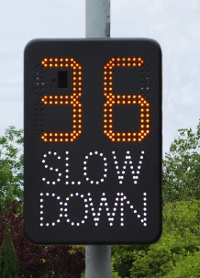We have our own Speed Indication Device which is deployed around the village at regular intervals to encourage drivers to observe the speed limits.

The Police Speed Enforcement Unit supports us by regularly monitoring speeds at various approved locations in the village and prosecuting offending drivers. We also have our HGV Watch group who, aided by CCTV at the cross roads in the centre of the village, monitor compliance with the weight limit by commercial vehicles passing through the village. The resulting evidence enables us to contact offending companies, whose drivers flaunt the Traffic Regulation Order, with a view to minimising illegal HGV traffic.

If you would like to join us in any of the above voluntary activities to make our village safer, please contact Rex Eastment – [rexeastment@talktalk.net](mailto:rexeastment@talktalk.net) or 07977 211150.

**Sports & Fitness**

**Pilates**

Pilates - mat based classes taught Monday evenings, 7pm and Wednesday mornings, 9am (beginners) and 10am. The classes are taught as courses and must be booked by contacting Lindsey Lloyd Tel: 01225 635830 or [village-Pilates@live.com](mailto:village-Pilates@live.com)

**Yoga**

There are three yoga classes in the Palairet Hall – one on a Tuesday 7.00 pm – 8.30 pm (and is £30 for a 5-week block or £8 for a drop-in.  There are two Friday classes, one from 10.00 am – 11.00 am, the second from 11.10 to 12.00. They are both less dynamic than the Tuesday class and may be more suitable for beginners.  The cost is £25 for a 5-week block and £7 for a drop-in.  Contact Barbara Lund 01373-834771 or 07846 335636 [barbilund@live.co.uk](mailto:barbilund@live.co.uk)

**Tennis** – the nearest club is Beckington. Information on this can be found at [www.beckingtontennis.co.uk](http://www.beckingtontennis.co.uk)

**Golf** – there are a number of golf clubs in the area – Orchardleigh on the outskirts of Frome [www.orchardleighgolf.co.uk](http://www.orchardleighgolf.co.uk) or Bath golf club on North Road near the University of Bath [www.bathgolfclub.org.uk](http://www.bathgolfclub.org.uk)

**Cricket**

NSP Cricket Club play friendly fixtures against local teams mainly on Wednesday evenings between April and September.  Home games are on the wonderful setting of Churchmead which ranked in the top 10 of the Daily Telegraph’s picturesque cricket grounds and has also featured in the August 2017 edition of Country Life.

We are a very social club and welcome enthusiastic players of all standards and ages as well as non-playing social members.  We also promote the development of Junior players through our excellent tri-village Junior Club.

For more information contact:-

Club Captain:  Rupert Foster 07793 440534

**DRAMA & FILM**

 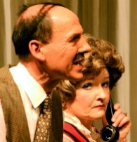 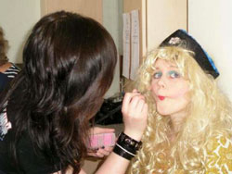 Based in Norton St Philip, Palairet Productions is a community group staging theatre productions including musicals, comedies and thrillers; hosting films and putting on community events. Originally established over 40 years ago as Philips Norton Players, we changed our name in 2015 to bring together our theatre productions, film nights (Palairet Pictures) and other activities under one name. We show films once a month at the Palairet Hall. Tickets are £5. Details of what’s on can be found on our website <https://www.palairetproductions.com/>. We’re a friendly and welcoming group and we’re always looking for people to help out. You could, for example, try out for a part in a play, help out at a film night or work on set design. Take a look at our website for more details. Whatever your interest and however much time you can spare, we will be happy to have you join us.

Facebook: [www.facebook.com/palairetproductions](http://www.facebook.com/palairetproductions)

Twitter: @palairetprods

Email: [hello@palairetproductions.com](mailto:hello@palairetproductions.com)

**Arts & Crafts**

**Norton St Philip Photography Club**

We are a group of local people who have an interest in taking photographs and sharing the results. We meet every two months, sometimes with a speaker. Since starting in 2010 we have held two well received exhibitions in the village. New members and guests are very welcome to join our meetings and outings. For more information contact Tony Day 01373-834438 or visit our web site <https://www.flickr.com/groups/nortonstphilip/>

**Norton St Philip Artists**

[](http://www.clothroadartists.com/)

In 2014 and 2016 a group of artists opened 9 venues in the village as part of the Cloth Road Arts Trail. There are several groups in the village who contribute to this event:-

**Creative Textiles Group**

This thriving group uses varied techniques such as embroidery, applique’, quilting, patchwork etc.  Occasional workshop sessions are arranged.  The group is full at present but please make enquiries if you have an interest in this area of work.  Please contact Heather Golland on 01373 834458.

**Knitting Group** – Anna Nixon 01373-834639

**Sewing Group** – Hilary Bodger 01373-834444

**Etching & Collograph Workshops** – Sandra Porter printmaking studio 01373-834802 [www.sandraporter.com](http://www.sandraporter.com)

**Brewery Barn** – in North St holds occasional exhibitions and hosts several groups. It is also available to hire for art exhibitions – contact 01373-834438 for further details.

**Libraries**

**Frome Library -** The library is a popular facility in the town. It has an extensive collection of books for adults on both floors, while the children’s library is on the ground floor. There are large collections of music, CD’s, DVDs and talking books.

A council access point is located near to the main entrance and the Frome Tourist Information Centre is also on the ground floor. Justice Lane, Frome Tel: 0845-345 9177.

A mobile library visits the village at Tellisford Lane estate on a **Monday** from 11.00 am – 11.20 am. For further information visit [www.somerset.gov.uk/libraries](http://www.somerset.gov.uk/libraries)

**The Village Shop**

We are delighted to have a village shop courtesy of the Coop. It is very well stocked with daily-delivered fresh fruit, vegetables, freshly baked bread, newspapers and much more. Co-op prides itself on seasonal offers, food to go and has a full off licence.

There is also a Post Office counter inside the shop which offers travel money and personal banking and is open the same hours as the shop.

There are frequently job opportunities – please ask in Store if you are interested. Don’t forget to apply for your Coop membership card to ensure maximum benefit.

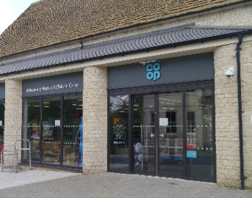**Opening Hours**

**7.00 am – 10.00 pm every day**

There is ample parking behind the shop.

Pubs

**FLEUR DE LYS**

**Opening Times**

Bar

Friday from 11am until midnight.

Sundays closed all day

Food

Monday to Saturday 5.30pm until 10 pm

Sundays closed

There is sometimes live music – check for further details.

Serving delicious pizzas, pasta and much more to eat in or take away, there are a range of pub games, pool, skittles and darts, pinball machine, BT sport live in HD, all in a beautifully atmospheric pub with an open fire and steeped in history. Contact 01373-834333 <http://www.fleurdelysnsp.co.uk/home>

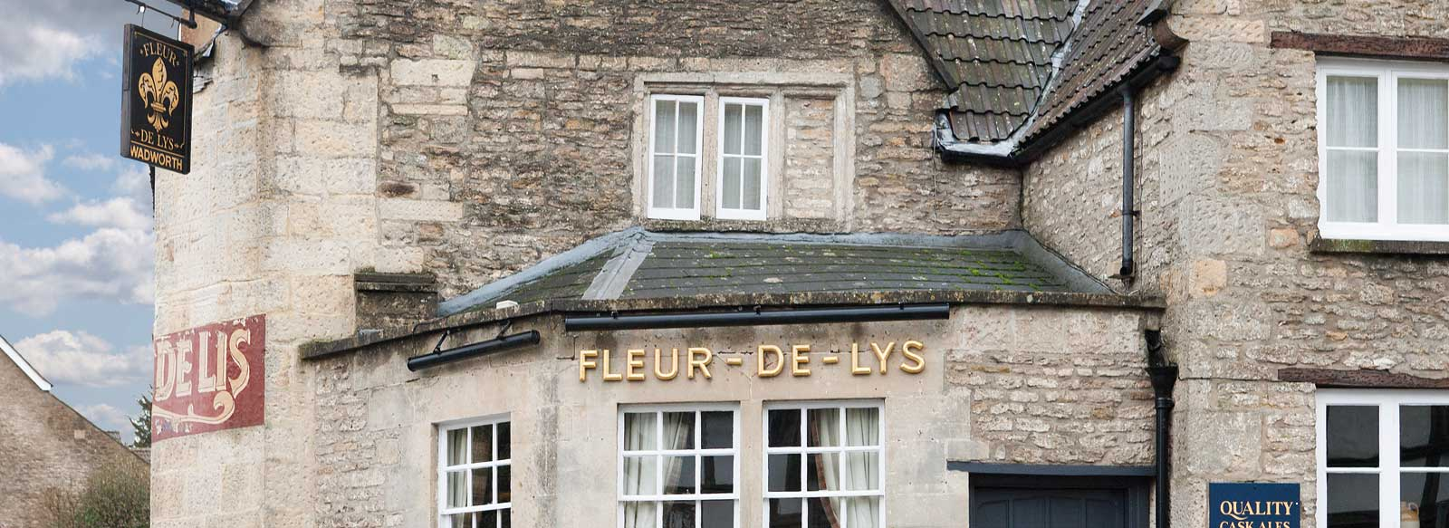

**GEORGE INN**

**Opening Times**

**Opening Times - Bar**

Monday – Thursday 10am -10 pm

Friday and Saturday 10am – 10.30 pm

Sunday 12 noon – 10 pm

**Food Serving Times**

Monday to Saturday from 5.30 pm in evenings

Sunday 12 until 8 pm

Serving customers since 1397, the George Inn is reputed to be one of the oldest continually licensed inns in the country. The grade I listed building still retains all its character with open fires, wood panelling and dungeon. The beer garden overlooks the Mead and the church to an award-winning view. Accommodation includes four-poster beds and en-suite bedrooms. The menu offers locally sourced produce served in the stunning dining room and bar areas. Contact 01373-834224 for reservations.

[www.georgeinnnsp.co.uk](http://www.georgeinnnsp.co.uk)

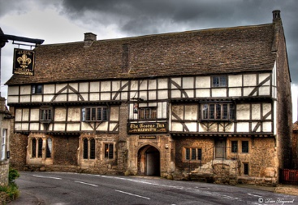

**Doctors and Hospitals**



**DOCTORS**

The Beckington Family Practice

Main Surgery: St Lukes Surgery, Beckington, BA11 6SE

Telephone Numbers:

Enquiries & Emergences 01373-830316 Appointments: 01373-830006

Out of Hours: 111

Branch Surgeries:

Freshford, BA2 7TT Tel: 01225-722356

Frome Medical Centre (nr Community hospital) Tel: 01373-464731

**HOSPITALS**

**Frome Community Hospital**, Enos Way, Frome, BA11 2FH

Tel: 01373-454740. For minor injuries only

**Royal United Hospital**, Combe Park, Bath, BA1 3NG

Tel: 01225-428331. Full A & E services

Bus service from Odd Down Park & Ride

**Public Transport**

First Bus Service D2 – Frome – Bath via Beckington, Rode, Norton St Philip, Midford. Services on Mon-Fri (except public holidays)

Services on Saturday and Sunday differ.

<https://www.firstgroup.com/bristol-bath-and-west/plan-journey/timetables/?operator=3&service=Frome&page=1&redirect=no>

There is also an alternative bus service X67 which avoids Rode. For up to date timetables go to <http://www.faresaver.co.uk/timetable.php>

**Train Services**

Bath Spa to London Paddington or Bristol. Bath Rail Station is 8 miles from the village and takes approximately 20-30 mins.

Trains from Bradford on Avon, Trowbridge, Warminster go to Waterloo, London which can be cheaper. Parking is also easier. Travel time to stations is 10-20 mins.

**The Ridings**

Community Car Service – If you need to go to the hospital or doctor contact 01225-722699.

**Your MP and Local Government**

**Member of Parliament**

**David Warburton** is the elected MP for Frome and Somerton. He can be contacted at his constituency office Tel: 01373 580500 based in Unit G9, Woodside Court, Dairy House Yard, Sparkford, BA22 7LH. Email: [david.warburton.mp@parliament.uk](mailto:david.warburton.mp@parliament.uk) and more information can be found on his web page <https://www.davidwarburton.org.uk/>

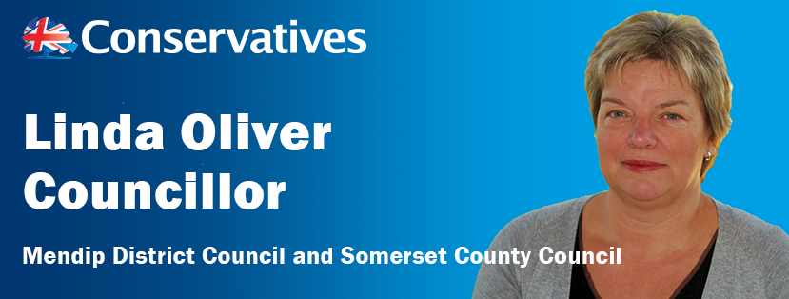**Linda Oliver** is your Mendip District Councillor and your Somerset County Councillor.. She works closely with Norton St Philip Parish Council and the Traffic Action Group Chair. The Parish Council is the first tier of local government and is a statutory body. The District and County Councils being the 2nd Tier.

Contact details:-UpperFarm Close, Norton St Philip, BA2 7NA

**Tel:** 01373 834210 **Mail:** [loliver@somerset.gov.uk](mailto:loliver@somerset.gov.uk)

[Cllr.oliver@mendip.gov.uk](mailto:Cllr.oliver@mendip.ov.uk) **Web:** [www.councillorlindaoliver.org.uk](http://www.councillorlindaoliver.org.uk)

**The role of a District & County Councillor**

* To provide a community leadership role in resolving issues relating to local council services.
* Any local issue should ideally, should first of all be raised with the Parish Council. [www.nortonstphilipparishcouncil.co.uk](http://www.nortonstphilipparishcouncil.co.uk)
* The issue may then be referred to Linda Oliver in order to assist in the communication either with MDC or SCC depending on the service involved. The responsibility for those services is broadly as follows: -

**County Councils- www.somerset.gov.uk**

These are responsible for services across the whole of a county, like:

* Education
* Transport & Highways
* Strategic Planning
* Passenger Transport
* Social care
* Libraries
* Waste management
* Trading standards

**District Councils-www.mendip.gov.uk**

These cover a smaller area than county councils. They’re responsible for services like:

* Environmental Health
* Council Tax collections
* Housing
* Planning applications
* Leisure & recreation
* Refuse collection

**Norton St Philip Parish Council**

The Parish Council (‘the PC’) serves the community in two main ways. First, it performs a limited number of roles at its own hand, for example facilitating a Neighbourhood Plan; gauging local opinion on issues of interest or concern (eg by conducting surveys and holding public meetings); promoting the use and protection of Public Rights of Way; and by giving grants. Secondly, it has a consultative and advocacy role, in particular as regards Mendip DC’s policies on planning issues (especially Mendip DC’s Local Plan Parts I and II); commenting on planning applications; offering views and advice to Somerset CC on highways matters (especially as regards road safety); and putting views to other bodies on issues of local significance or concern. The PC is a *statutory* body, and is a statutory consultee on, for example, planning applications. It is the *first* tier of local government, ie the tier closest, day to day, to the community.

The PC meets on the second Wednesday of each month. Members of the community are welcome to attend, and at the start of each meeting there is a Public Participation section in which the public can raise issues and express views. In addition to the PC’s monthly meetings, there is, each May, an Annual Parish Meeting, which provides the opportunity for the public to comment on the previous year, make suggestions for the year ahead, and raise other issues for the PC to consider.

The Chairman of the PC is Ian Hasell and the Clerk is Ms Nicola Duke (01373 864127). E-mail [nortonstphilippc@aol.com](mailto:nortonstphilippp@aol.com) Visit the PC’s website [www.nortonstphilipparishcouncil.co.uk](http://www.nortonstphilipparishcouncil.co.uk) to find out more, including information about current members of the PC.

**Service for Household Waste in Mendip**

Collection Day is normally **TUESDAY (Wednesdays after a bank holiday)**

This includes kerbside collections for weekly recycling and food waste.

**Paper –** newspapers, magazines, leaflets, directories, white envelopes (no need to remove windows) and other white paper.

**Glass bottles and jars** – rinsed and unbroken (no table or cookware)

**Foil** – please bag, aluminium foil only and not if plastic or paper backed

**Food and drink cans** – rinsed and squashed if possible, no need to remove labels.

**Aerosols** – only recycle empty, used up aerosols; do not attempt to pierce or squash them, if you can remove the plastic cap and nozzle.

**Plastic bottles** – no tops; please rinse, especially milk bottles; no pots, tubs trays or film. Exclude bottles that have contained garden or DIY chemicals or engine oil.

**Cardboard** – brown corrugated, grey card, greetings cards and brown envelopes – please flatten.

**Domestic refuse is collected fortnightly** – (green or black bins) – if you have a wheeled bin for refuse, please use this. If your property is unsuitable for a wheeled bin up to 4 sacks of refuse will be accepted each collection.

Refuse should be put out on the edge of your property by 7.00 am (collection times can vary) and no earlier than the night before. Sacks of refuse can be put out inside your wheeled bin. The lid should be closed when put out for collection and only refuse in the bin will be collected. Extra refuse on top or alongside will not normally be taken.

**Garden Waste** – collections fortnightly for subscribers only.

Larger items should be taken to the nearest recycling site at Manor Furlong, Manor Rd, Frome, BA11 4RN.

Further information is available at www/.mendip.gov.uk

**The Friends’ Page**

***The Friends*** of St Philip and St James is an informal association of community and church people led by a committee (Steering Group) which acts as a sub-committee of the Parochial Church Council (PCC) of the Parish of Hardington Vale. The association exists to support the maintenance and upkeep of our beautiful 14th century church. ***Friends*** organise occasional fund-raising events, undertake projects like spring cleaning and help with the upkeep of the churchyard.

JOIN IN: ***THE FRIENDS*** welcomes volunteers with fresh ideas to help with routine or occasional tasks. Residents in the village and others who are interested in this 14th century building are invited to become involved in the work of maintaining the church and churchyard in a variety of different ways. These include: bell-ringing, flower-arranging, gardening, baking, knitting, maintenance of building and churchyard, painting and decorating, care of fabrics, clock winding, photography, singing, playing a musical instrument, and spring-cleaning. The church is open every day and locking is undertaken by a team of volunteers. The church attracts a considerable numbers of visitors as well as people just wishing to pop in for a few quiet moments.

If you have a penchant for any task let us know and we will find a niche for you! Friends’ Joiner Forms can be obtained from either of the two church wardens (Muriel Duckett on 834581 or Glenys Brown on 834226 ) or from the Parish Office which is open Monday-Wednesday 8.30 am – 12.30 pm.

**KEEPING IN TOUCH**

**Hardington Vale Parish Website**

[www.hardingtonvale.org.uk](http://www.hardingtonvale.org.uk)

This web site contains lots of information both current and historical and is regularly updated.

**Parish News Magazine**

The Parish News is published eleven months of the year and contains feature articles, calendars of events, details about clubs and societies, and adverts for local businesses. To receive your regular monthly copy of the Parish News contact the subscriptions manager [jennymariemiddleton@gmail.com](mailto:jennymariemiddleton@gmail.com) or visit **https://hardingtonvale.org.uk/parish-news-magazine/**

Parish News is produced by a team of volunteers for the benefit of the community. Currently the editorial team consists of John Dixon, Phil Dutton, Jenny Middleton and Philip Miller. The Editors would welcome more volunteers prepared to collate and edit the magazine three or four times a year and also occasional contributors. The Editorial team would welcome more advertisements – please contact Parish News.

For more information contact [parishnewscopy@gmail.com](mailto:parishnewscopy@gmail.com)

Last edited 6/1/2020